PE_PRN211_SP24_TrialTest
SPRING 24
Subject: PRN211
Duration: 90 minutes (upload the solution within 4 minutes before the deadline – due to the heavy traffic of network)

INSTRUCTIONS
Please read the instructions carefully before doing the questions.
- You are NOT allowed to use any other materials. You are NOT allowed to use any device to share data with others.
- You must use IDE as Visual Studio 2019 or later, MSSQL Server 2016 or later database for your development tools.
IMPORTANT – Before you start doing your solution, MUST do the following steps:
- To do your program, you must use Windows Forms, apply 3-Layer architecture. Note that you are not allowed to connect directly to database from WindowsForms, every database connection must be used with Repositories and Data Access Objects/Services . The database connection string must get from appsettings.json file. In the case your program connects directly to database from WindowsForms or you hardcode connection string, you will get 0 mark.
- If there are syntax errors or compilation errors in your PE program, you will not pass the PE requirements, the mark will be 0.
- Create Solution in Visual Studio 2019/2022 named PE_PRN211_SP24_PracticalTest_StudentName. Inside the Solution, Project Windows Forms named: BookManagement_StudentName.
- Create your MS SQL database named BookManagementDb by running code in script BookManagementDb.sql.
- Set the default user interface for your project as Login form.

Create an application using Windows Forms with .NET5/.NET6/.NET7, C#, and ADO.NET (or Entity Framework Core). A MS SQL Server database will be created to persist the data and it will be used for reading and managing data.
The below Figure is a part of BookManagementDb database.
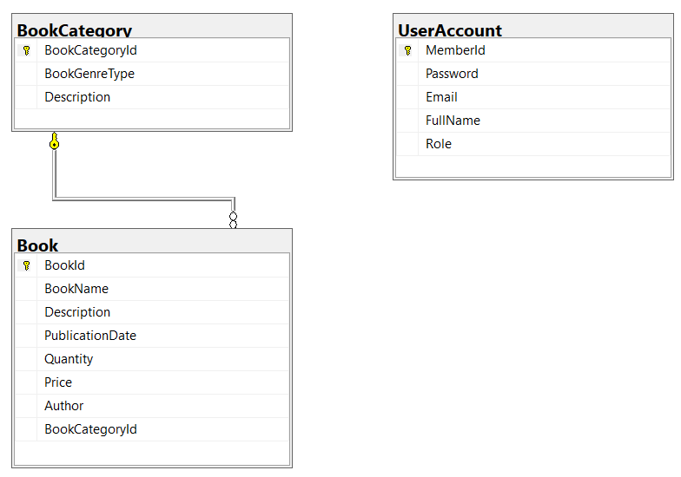
Note that: User role: Administrator = 1; Staff = 2; Member = 3. A book category will have many books, a book will belong to only one book category.

Task 1. Design graphic user interface and project organize with 3-Layer architecture.
- (0.5 mark) Design Login form includes UI controls for login function.
- (0.5 mark) Design Book Management form, this form includes UI controls for CRUD actions with book information. Note: The BookCategoryId/BookGenreType will come from the BookCategory table. Design a form which allows you to view the list of records, create a new item, update the existing item, and delete a specific item.
Task 2. Implement CRUD actions with GUI.
- (1.0 mark) Authentication function
If user with a Administrator role logs in successfully (using email address/password for login process), save this information to a temporary parameter. All CRUD actions are required authentication with Administrator role. In the case login unsuccessfully, display “You have no permission to access this function!”.
- (2.0 marks) Check if login successfully with Administrator role, list all books in Book table (the information includes BookId, BookName, Description, PublicationDate, Quantity, Price, Author, BookCategoryId and BookGenreType – book category name).
- (1.0 mark) Check if login successfully with Administrator role, search book information by BookName or Description (using relative search).
- (1.0 mark) Check if login successfully with Administrator role, delete the selected item with the confirmation then update the list of books.
- (2.5 marks) Check if login successfully with Administrator role, add new item with the requirements:
- The BookCategoryId/BookGenreType (book category id, book genre type) will come from the BookCategory table (you can use ComboBox UI control in this case)
- All fields are required.
- Value for Price and Quantity is greater than or equal to 0 and less than 4 000 000.
- Value for BookName (the name of the book) is in the range of 5 – 90 characters. Each word of the BookName must begin with the capital letter. BookName is also allowed with special characters.
- (1.5 marks) Check if login successfully with Administrator role, update an existing item.
- You can use your different form or use the data grid view for this update function (update by BookId). With update function, the same validation requirements with Add function.

